Lesson 6: Teacher Reference

Ramp Setup Instructions

Step 1: locate one board so that its end is against a wall. This board will be the braking ramp. Locating it here will ensure that the cart hits the wall rather than falling off the braking ramp if it ever gets to the end of it.

Step 2: Push the other pieces of wood firmly against the braking ramp. Tape the two pieces of wood across the top seam.

Step 3: Cut an index card to fit the width of the board. Lay it over the taped seam. Tape the index card in the intersection of both pieces in order to make this section smoother for the car to roll over. Add more tape on top of the index card. Flattened the tape.

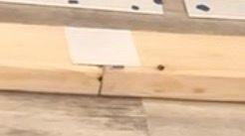 |  | 

Step 4: Add ticky tack along the vinyl blind in multiple locations.

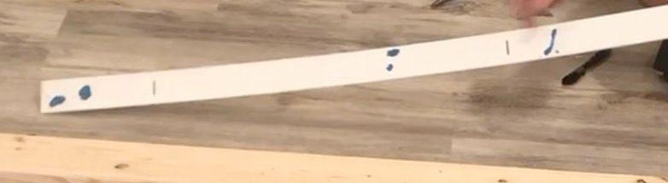 | 

Step 5: Line the edge of the end of one blind up with where the boards meet. Center it on the board. Push down on it to secure it in place. Do the same with a second vinyl blind on the second board. . Add tape on the ends to secure the blinds to the board. Add tape over where the blind ends meet.

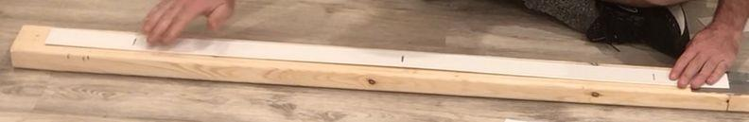 |  | 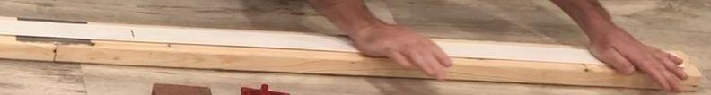
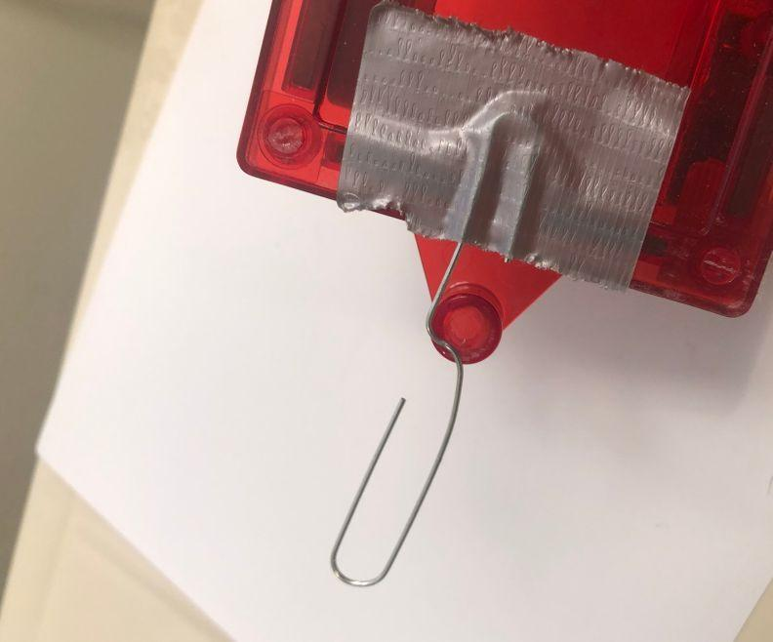
Step 6: Bend a paper clip into an S-hook shape. Tape one end of it to the end of the cart.

Step 7: Flip the cart upside down, center in the middle of the brick. Tape the brick around the cart, making sure that the tape does not touch the wheels and that the brick does not move in any direction. You may need to tape down the corners of the cart to the brick as well.

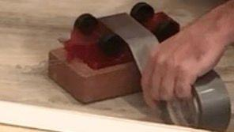 | 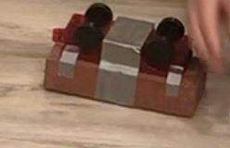 | 

Step 8: Set the end of the release launching ramp to a height of about 4.75 inches, by placing a two boxes under it stacked as shown in the image below. Set the end of the braking ramp to a height of 3.25 inches, by placing a single box under it, so that its narrowest face is against the floor.

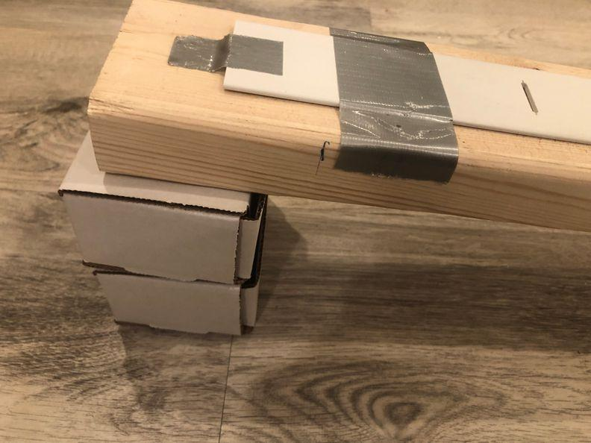 | 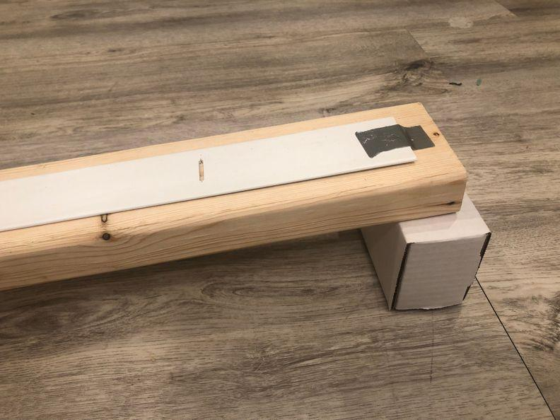 | 

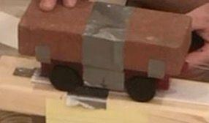
Step 9: Test the launching site distance to ensure that it does not fall off for this lowest braking ramp height:
- Start releasing the cart closer at the bottom of the ramp. See how high it travels on the braking ramp.
- Repeat, increasing the release height until you find a release height that results in the front of the cart stops 6 to 12 inches short of the end of the braking ramp.
- Mark this starting line with tape and/or marker.

Step 10: Label the corresponding locations on the system using sticky notes, as shown in the diagram below. This will help orient students to the system.
